Exp. No: 3 Determination and plotting of Force of attraction between two electric Charges and two parallel conductors separated by varying distance.
Date:
Aim:
To Determination and plotting of Force of attraction between two electric Charges and two parallel conductors separated by varying distance between them using SCILAB.

Software required:
- SCILAB version 6.0.1

Program:
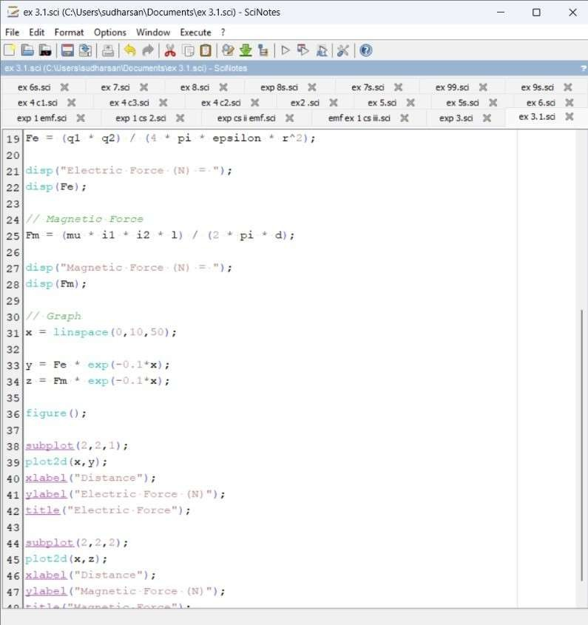

Output:

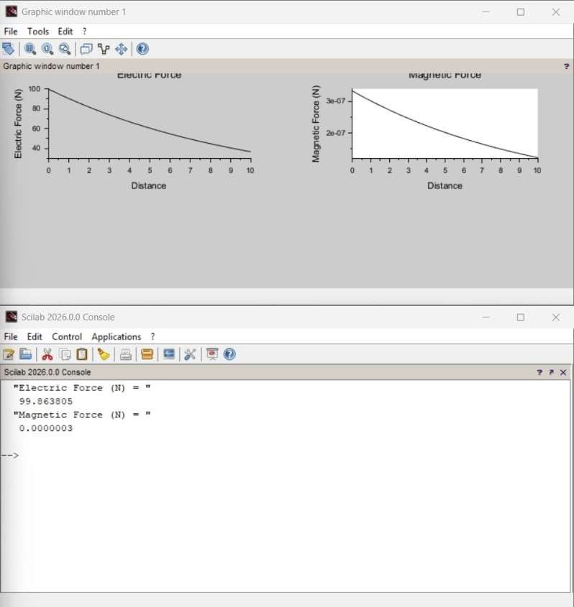

Calculation:
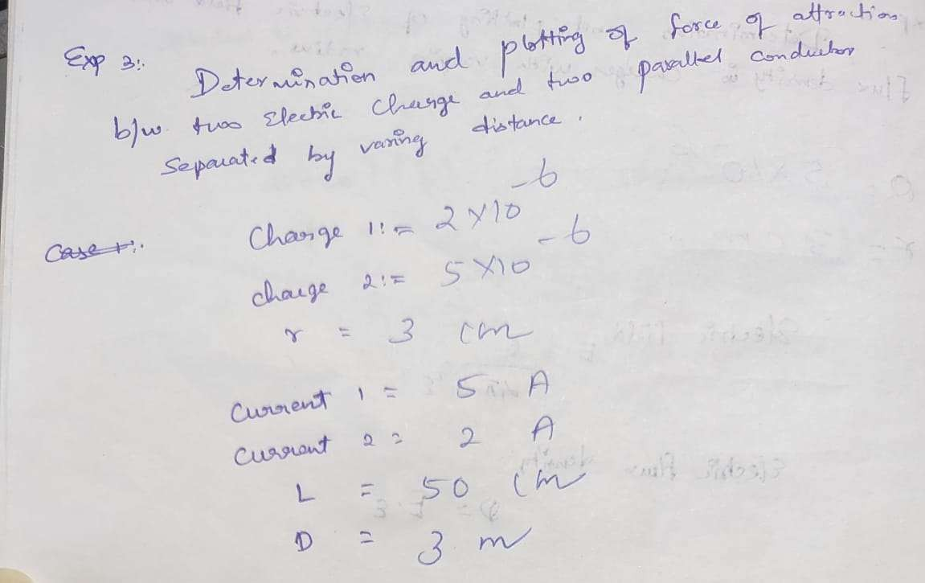
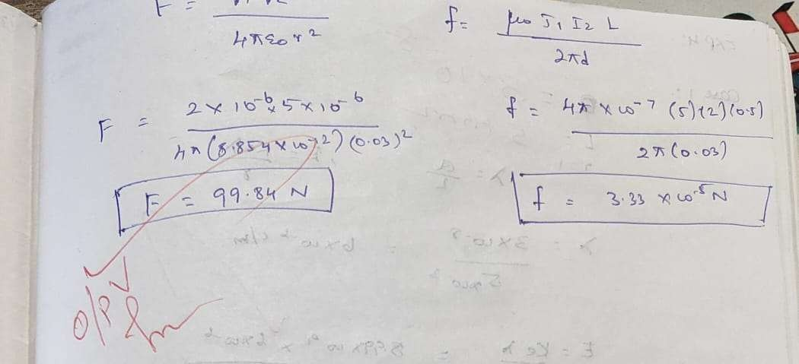

Case 2 :
Given two point charges q1=2×10^−6 and q2=3×10^−6 C, calculate and plot the force of attraction between them as a function of distance, ranging from 0.1 m to 10
m. Explain how the force changes with the distance between the charges.

Program:

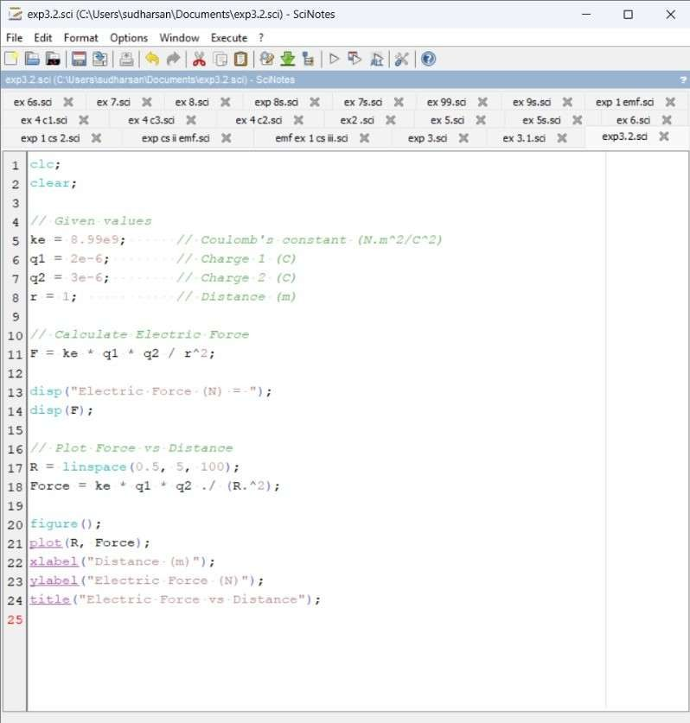

Output:

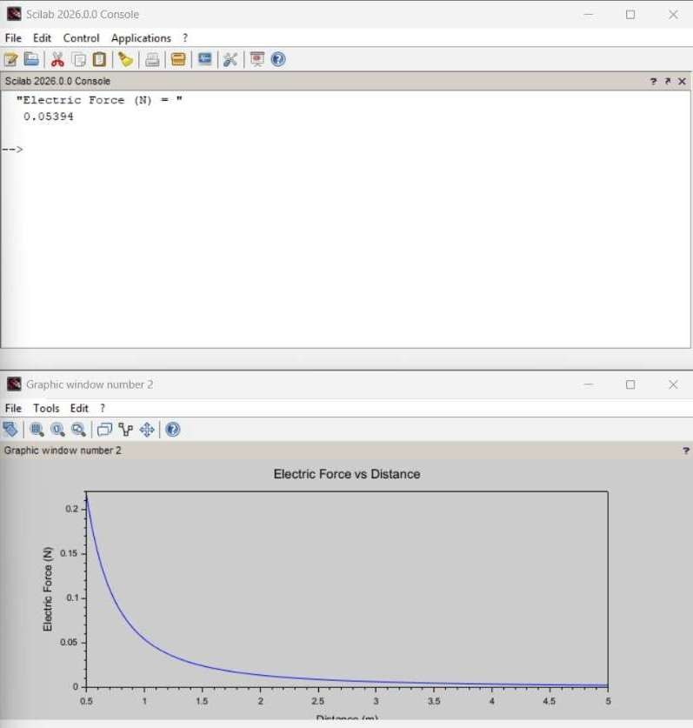
Calculation:
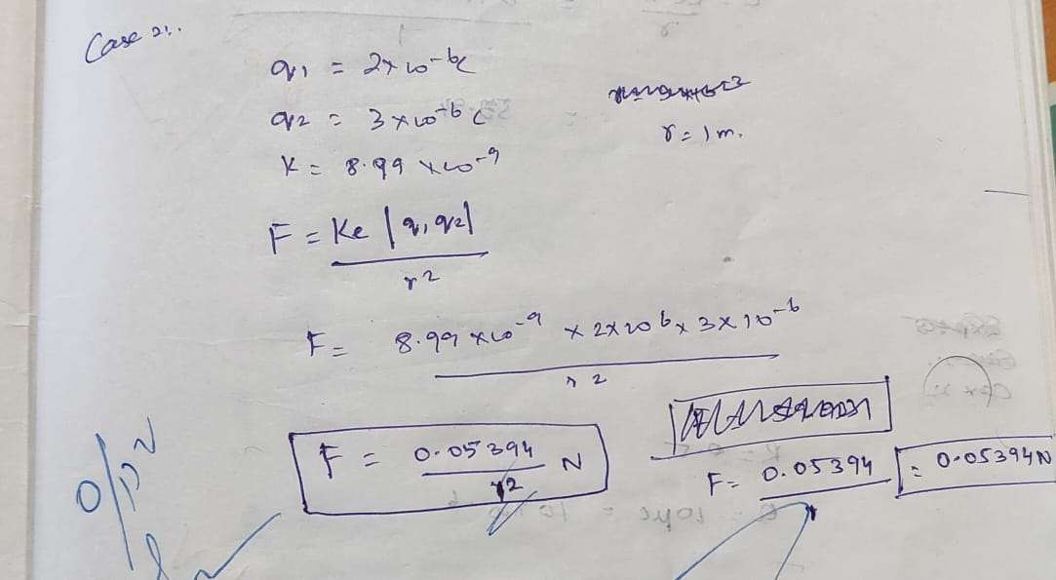

Case 3:
Given two point charges q1=5×10^−6 C and q2=2×10^−6 , calculate and plot the force of attraction between them as the distance varies from 0.5 m to 5 m. Discuss how the force behaves with the varying distance and charge magnitudes
Code:
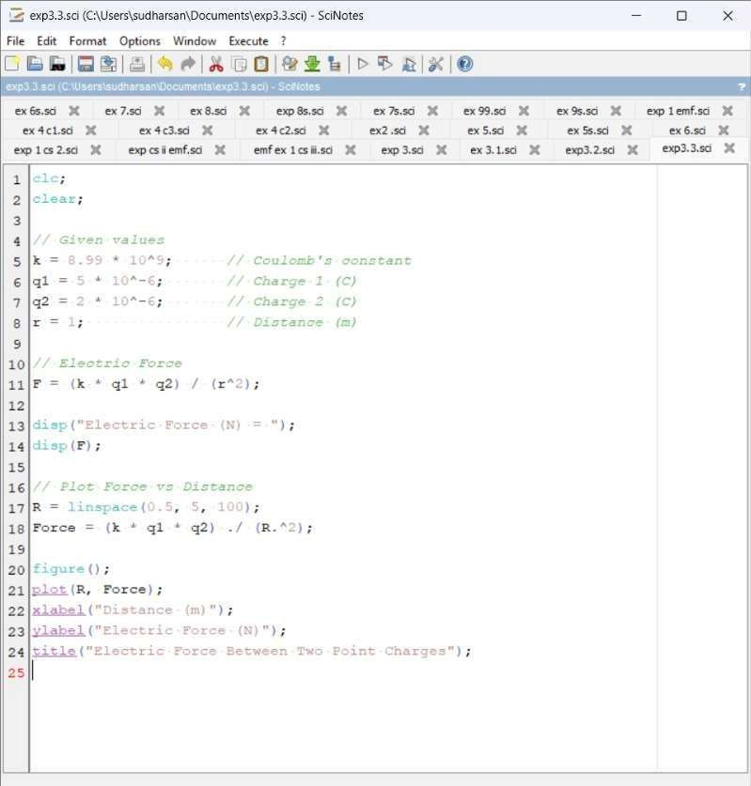
Output:

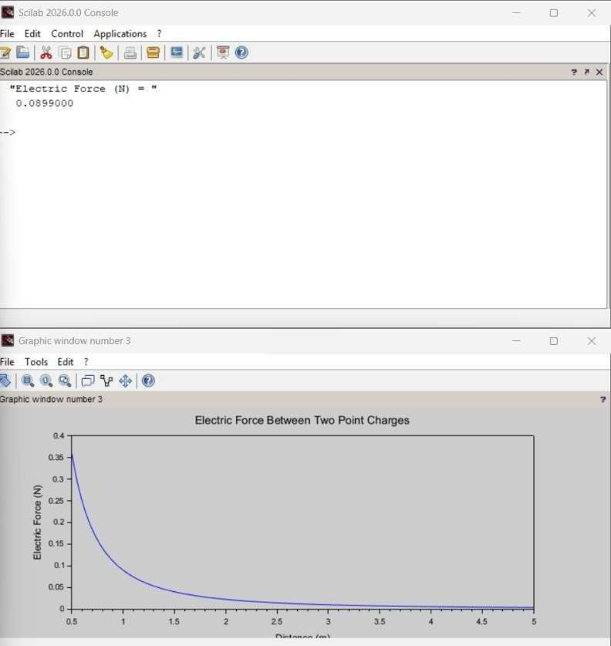
Calculation:

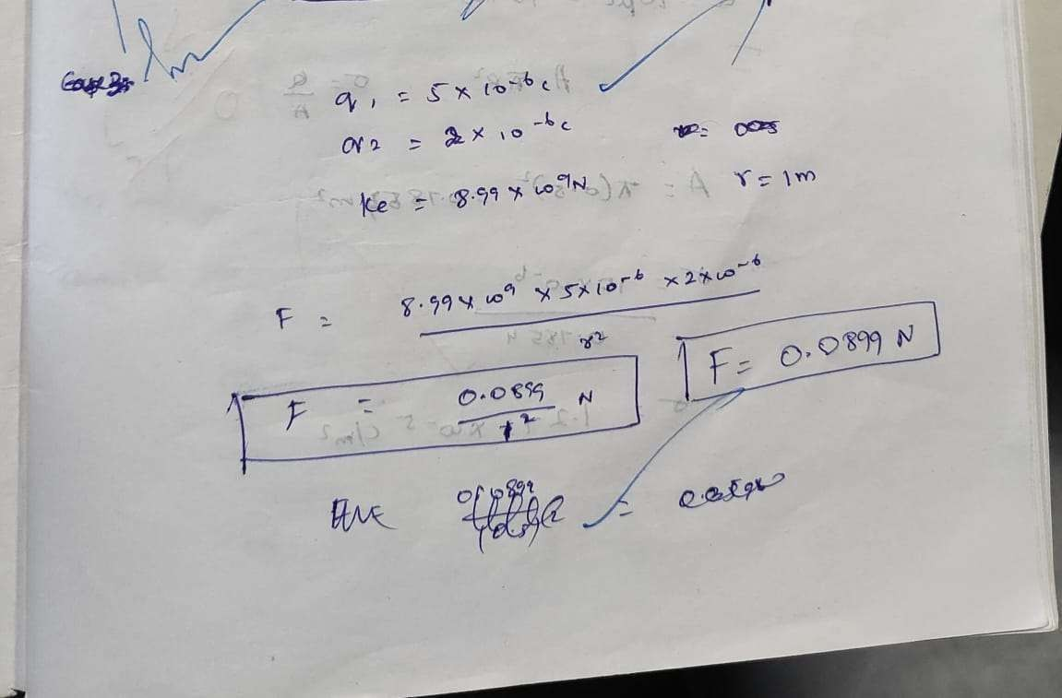
Result :
Thus the program was verified for the force of attraction or repulsion acting along a straight line between two electric charges is directly proportional to the product of the charges and inversely to the square of the distance between them using SCILAB was successfully.

